

DLD Lab-13

Counters



NATIONAL UNIVERSTIY OF COMPUTER AND EMERGING SCIENCES, FAST- Peshawar Campus

Department Of Computer Science

Instructor: Engr. Waseem Ullah

EL1005 – Digital Logic Design-Lab

SEMESTER SPRING 2022

Contents

1. Counters 2

2. Pin Configuration of ICs 2

3. Asynchronous Up Counter 2

4. Synchronous Counter (Up/Down) 4

# Counters

A register that goes through a prescribed sequence of states upon the application of input pulses is called a counter. The input pulses may be clock pulses or may originate from some other source, and they may occur at fixed intervals of time or random intervals. The sequence of states may follow the binary number sequence or any other sequence of states: A counter that follows the binary number sequence is called a binary counter.

Counters are available in two categories: ***ripple counters and synchronous counters***. In a ripple counter, the flip-flop output transition serves as a source for triggering other flip-flops. In other words, the clock inputs of some or all of the flip-flops are triggered not by the common clock pulses, but rather by the transition that occurs in other flip-flop outputs. In a synchronous counter, the clock inputs of all of the flip-flops receive the common clock pulse, and the change of state is determined from the present state of the counter.

# Pin Configuration of ICs

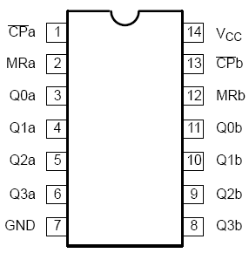

74393

# Asynchronous Up Counter

**Block Diagram:**

|  |
| --- |
| http://www.nzdl.org/gsdl/collect/gtz/archives/HASH01bf.dir/p66a.gif |

**Asynchronous Up Counter**

**Block Diagram:**

|  |
| --- |
| d.jpg |

# Synchronous Counter (Up/Down)

**Block Diagram:**

|  |
| --- |
| https://www.ee.usyd.edu.au/tutorials/digital_tutorial/part2/pics/count07.jpg |

**Counting Sequence**

|  |  |  |  |  |
| --- | --- | --- | --- | --- |
| **DOWN/UP** | **Q0** | **Q1** | **Q2** |  |
| 1 | Count Up | | | |
| 0 | Count Down | | | |

***Procedure***

1. Connect the trainer with the power supply
2. Supply the VCC and GND to the pin 16/14 and 8/7 respectively
3. Wire the pins of IC according to the diagram, refer to the pin configuration of ICs.
4. Drive Up/Down with the input switch on the trainer board and CP input from the clock on the trainer board. Connect output Q’sto LEDs.
5. Connect reset input to the switch. When high will reset the counter.
6. Observe and record the output on the LEDs.